  - Data Set Overview

The table below lists each of the files available for analysis with a short description of what is found in each one.
File Name | Description | Fields
ad-clicks.csv | A line is added to this file  when a player clicks on an  advertisement in the  Flamingo app. | • timestamp: when the click occurred.  • txId: a unique id (within ad-clicks.log) for the  click  • userSessionid: the id of the user session for  the user who made the click  • teamid: the current team id of the user who  made the click  • userid: the user id of the user who made the  click  • adId: the id of the ad clicked on  • adCategory: the category/type of ad clicked  on
buy-clicks.csv | A line is added to this file  when a player makes an inapp purchase in the  Flamingo app. | • timestamp: when the purchase was made.  • txId: a unique id (within buy-clicks.log) for the  purchase  • userSessionId: the id of the user session for  the user who made the purchase  • team: the current team id of the user who  made the purchase  • userId: the user id of the user who made the  purchase  • buyId: the id of the item purchased  • price: the price of the item purchased
users.csv | This file contains a line for  each user playing the game. | • timestamp: when user first played the game.  • userId: the user id assigned to the user.  • nick: the nickname chosen by the user.  • twitter: the twitter handle of the user.  • dob: the date of birth of the user.  • country: the two-letter country code where  the user lives.
team.csv | This file contains a line for  each team terminated in  the game. | teamId: the id of the team  • name: the name of the team  • teamCreationTime: the timestamp when the  team was created  • teamEndTime: the timestamp when the last  member left the team
teamassignments.csv | A line is added to this file  each time a user joins a  team. A user can be in at  most a single team at a  time. | • timestamp: when the user joined the team.  • team: the id of the team  • userId: the id of the user  • assignmentId: a unique id for this assignment
level-events.csv | A line is added to this file  each time a team starts or  finishes a level in the game. | timestamp: when the event occurred.  • eventId: a unique id for the event  • teamId: the id of the team  • teamLevel: the level started or completed  • eventType: the type of event, either start or  end
user-session.csv | Each line in this file  describes a user session,  which denotes when a user  starts and stops playing the  game. Additionally, when a  team goes to the next level  in the game, the session is  ended for each user in the  team and a new one  started | • timestamp: a timestamp denoting when the  event occurred.  • userSessionId: a unique id for the session.  • userId: the current user's ID.  • teamId: the current user's team.  • assignmentId: the team assignment id for the  user to the team.  • sessionType: whether the event is the start or  end of a session.  • teamLevel: the level of the team during this  session.  • platformType: the type of platform of the user  during this session.
game-clicks.csv | A line is added to this file  each time a user performs a  click in the game. | timestamp: when the click occurred.  • clickId: a unique id for the click.  • userId: the id of the user performing the click.  • userSessionId: the id of the session of the user  when the click is performed.  • isHit: denotes if the click was on a flamingo  (value is 1) or missed the flamingo (value is 0)  • teamId: the id of the team of the user  • teamLevel: the current level of the team of the  user

  - Aggregation

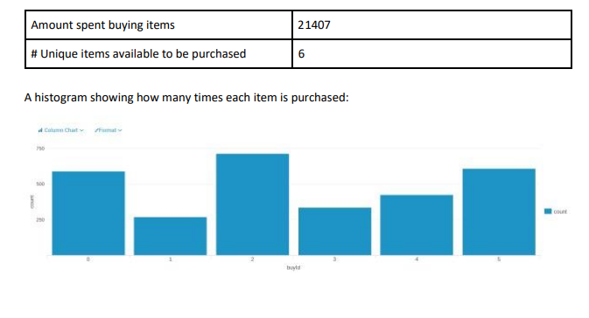

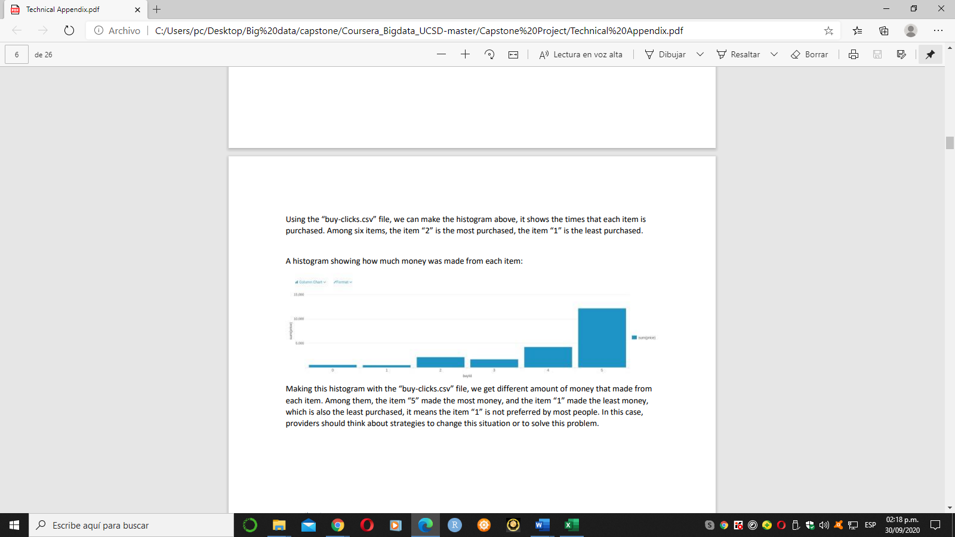
  - Filtering

